

School Of Engineering And Technology Computer

Science And Engineering Department Navrachana University, Vadodara

Fourth Year B.Tech CSE (Semester 7)

Academic Year

2024-2025

ARVR

Parv Gosani (21124033)

Course In-Charge: Darshan Parmar

# Introduction

This project (Fruit Ninja VR Unity) was carried out in fulfillment of a course requirement to study virtual reality development with unity. I aimed to make an immersive VR environment which allows players to interact with Grabbable objects, implement some base interactions present in a basic VR game and Build Game Logic similar to Fruit Ninja. Such a report shall narrate the complete journey of executing this project, detailing each aspect and an encounter with any challenges we faced during our agile development framework.

# Task 1: Set Up Unity Project & Configure VR Environment

In this work, I first built up the Unity project and prepared the VR environment to allow interaction with a VR headset. The project was built up with the most recent version of Unity, which has VR compatibility, and appropriate SDKs were incorporated.

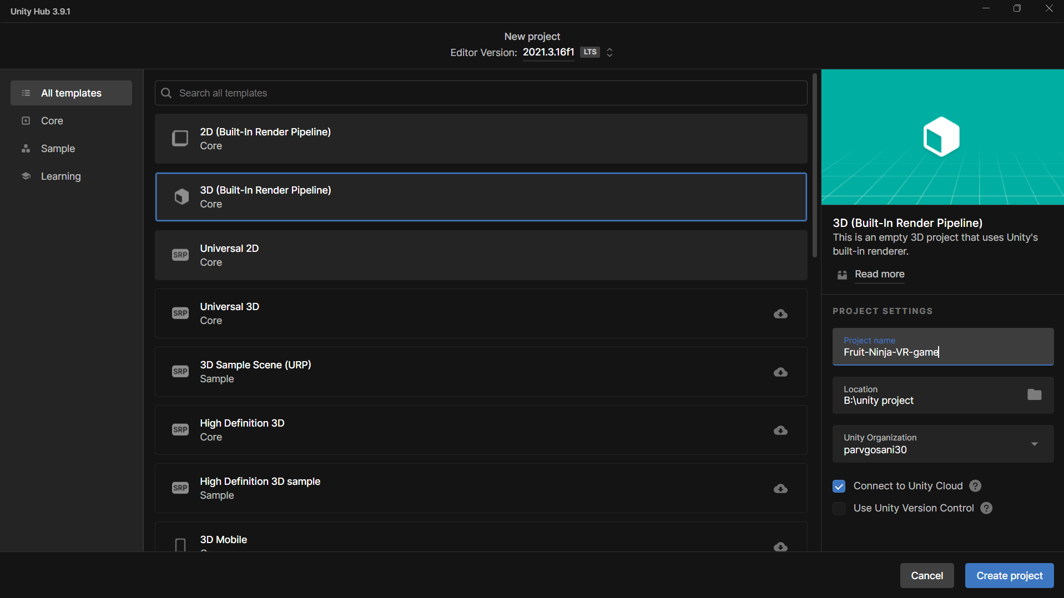

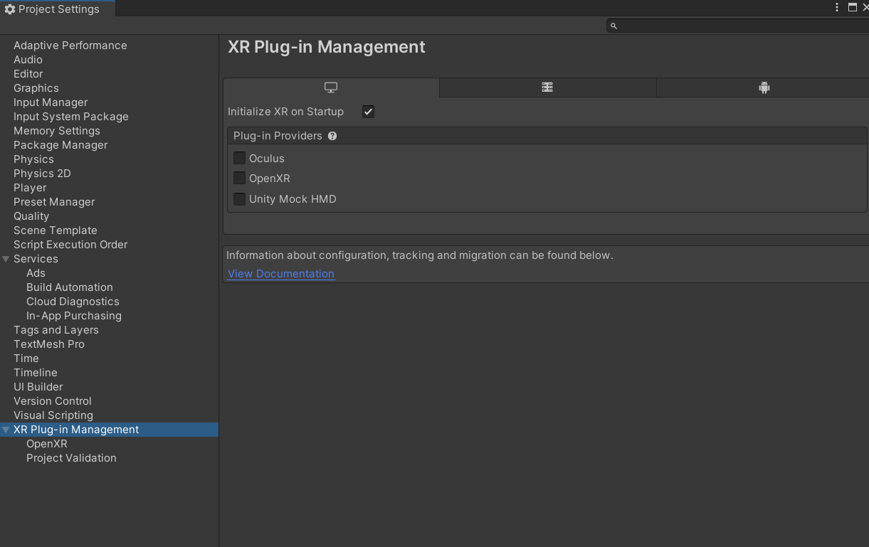

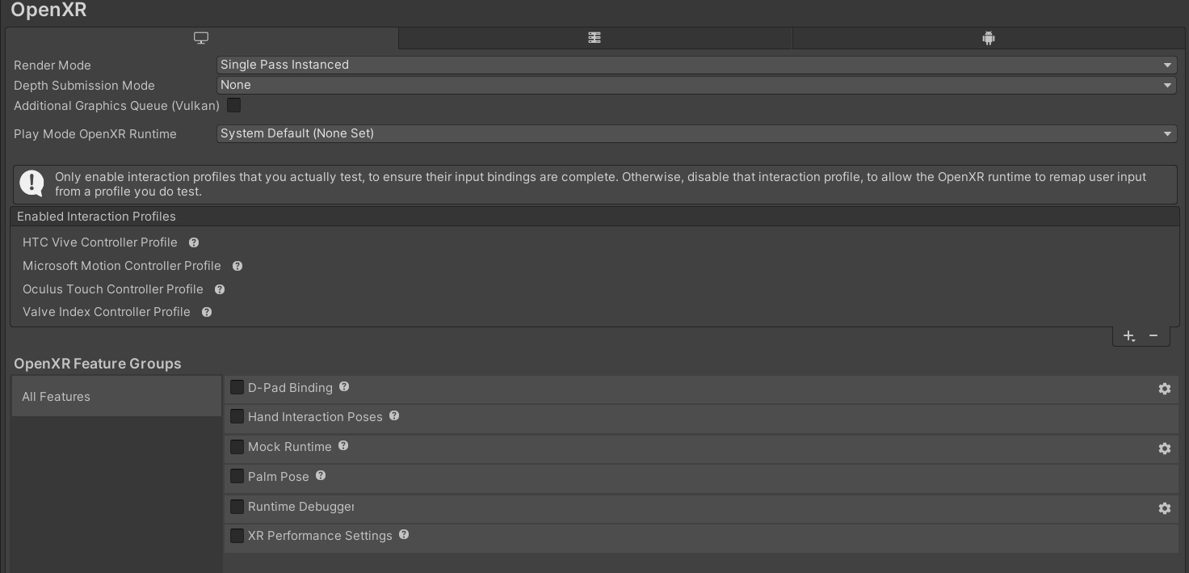

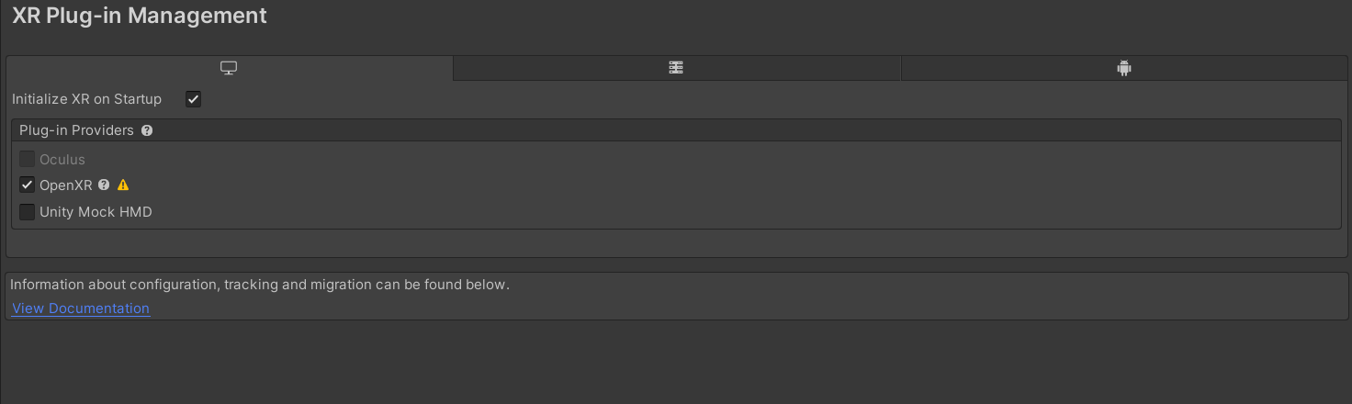

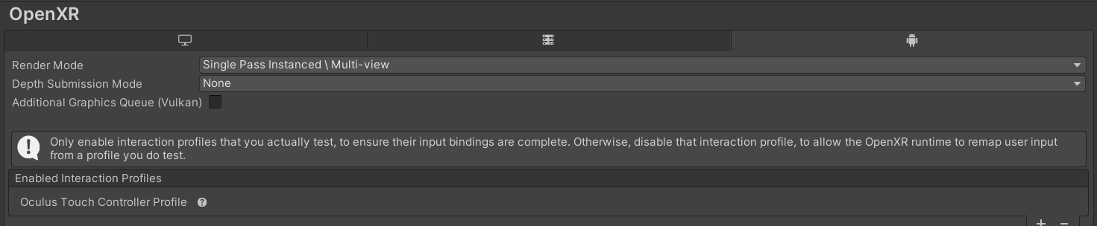

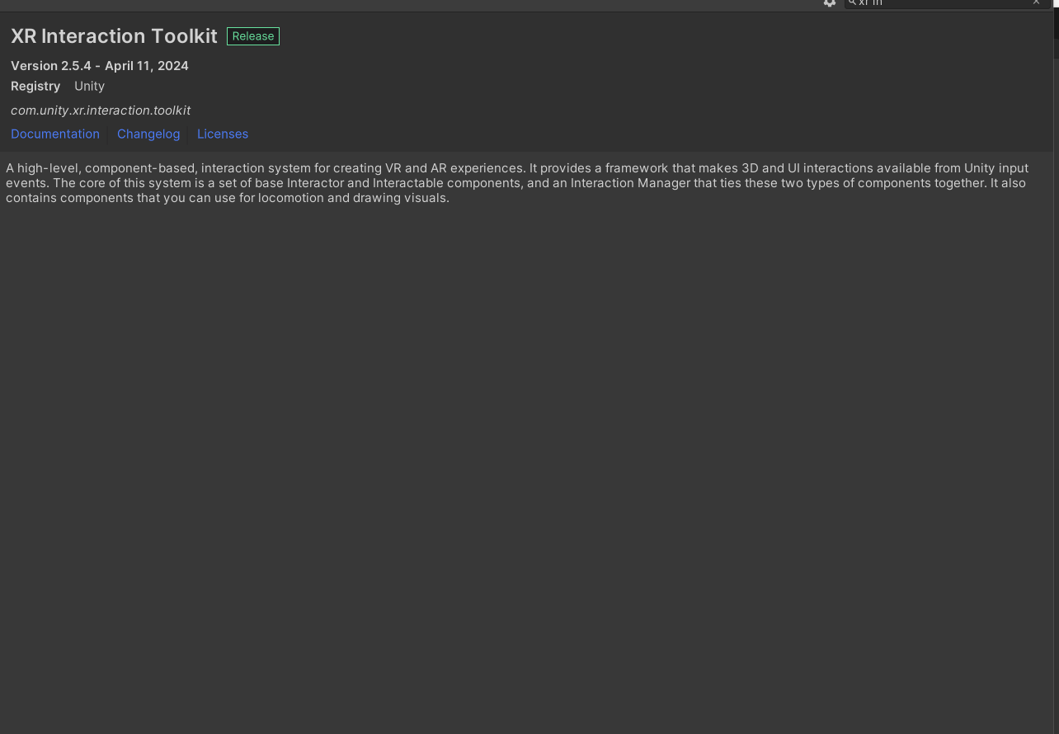

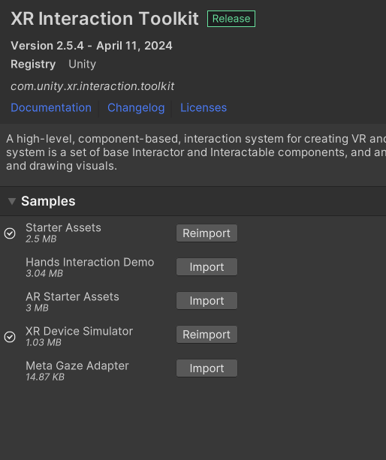

# Task 2: Create Ground Plane and Skybox

**Actions: -**

* Ground Plane: - To enable unfettered mobility in VR, I developed a big ground plane with Unity's terrain object. The size was adjusted to accommodate VR movement, ensuring the user has adequate area to explore.
* Skybox: - Then I used a pre-existing skybox material from Unity's Asset Store to visually improve the environment, replicating a bright and clear day.

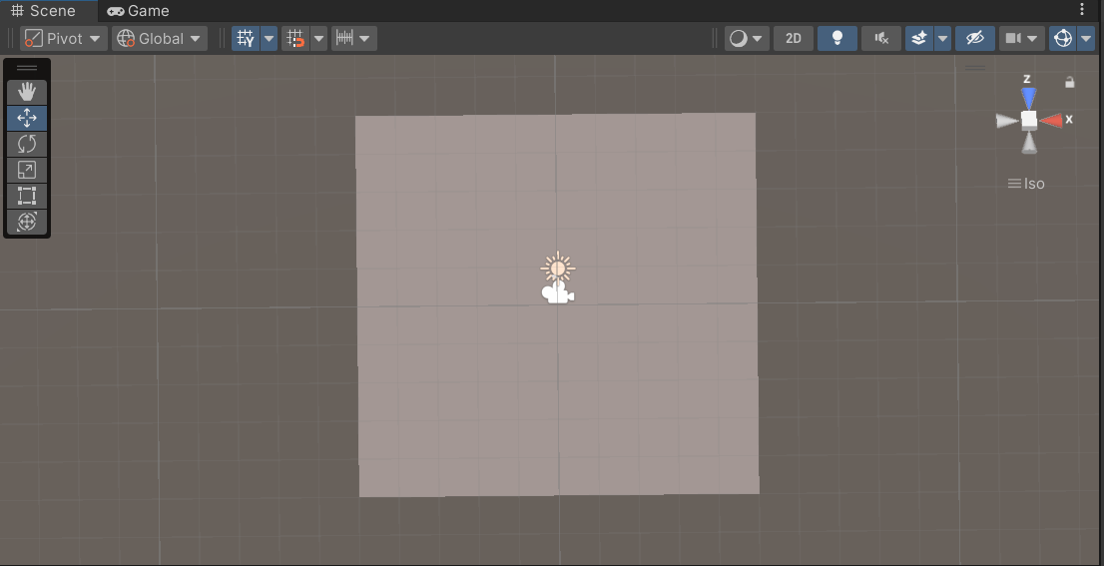

## 

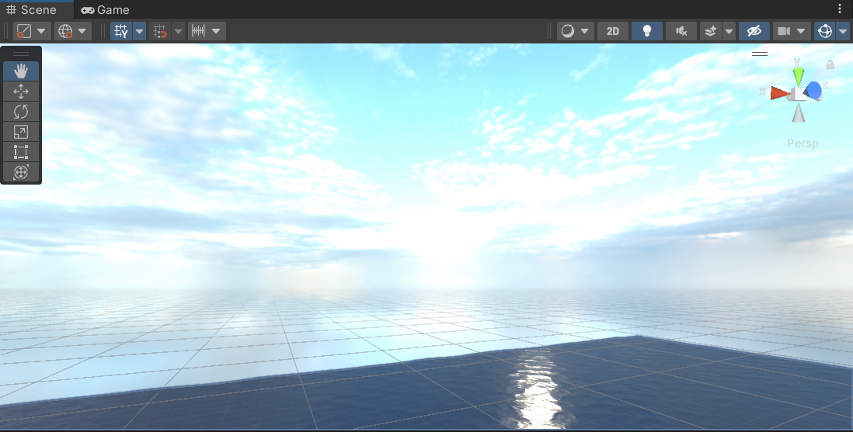

# Task 3: Add Environmental Objects

**Actions: -**

* Environmental Assets: - I imported a variety of environmental assets, like trees, rocks, and structures, to make the setting more immersive.
* Grabbable Objects: - I created prefabs of fruits (such as watermelons and oranges) that spawn randomly over the area at varying intervals, making interaction more dynamic.

link: - <https://assetstore.unity.com/packages/3d/vegetation/trees/japanese-garden-pack-179492>

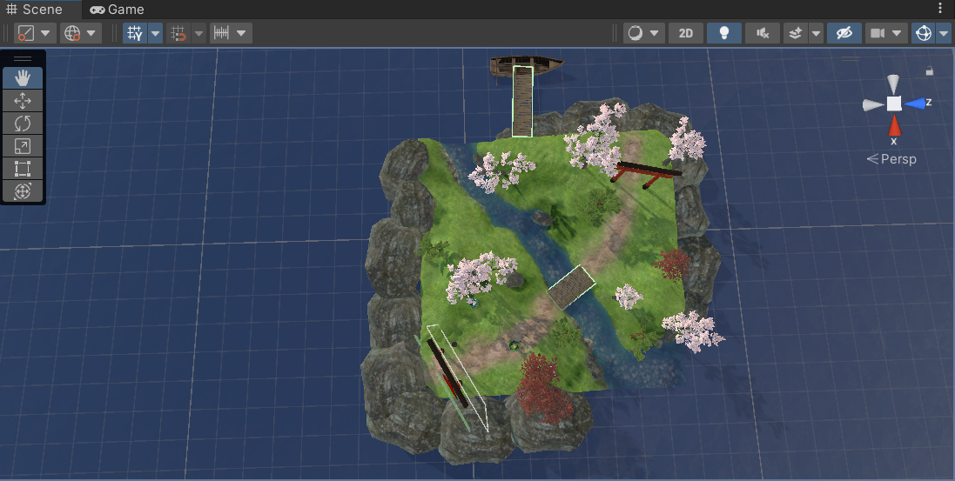

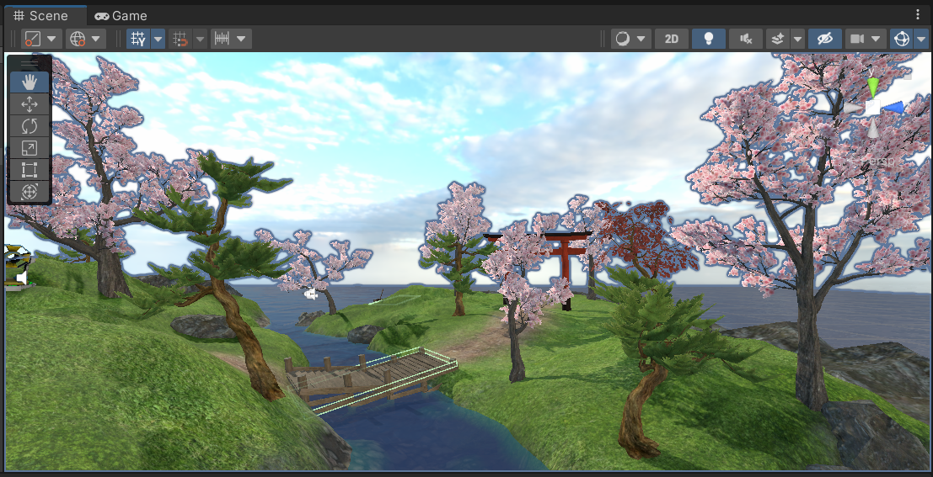

# Task 4: Configure Lighting and Shadows

**Actions: -**

* Lighting: - Configure directional lighting to represent sunshine, ensuring sure it matches the skybox and surroundings.
* Shadows: - Added real-time shadows to dynamic objects to improve the immersive experience.

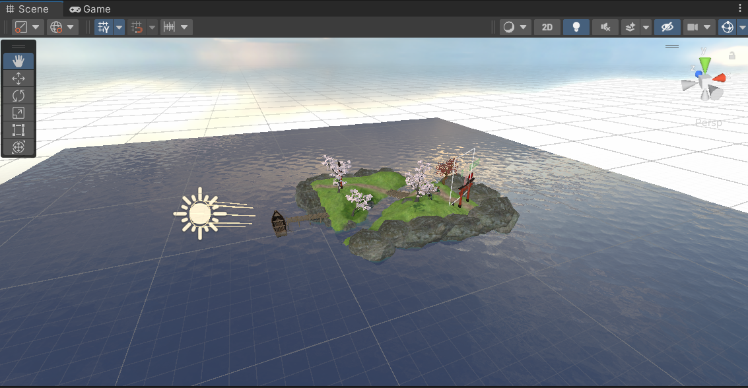

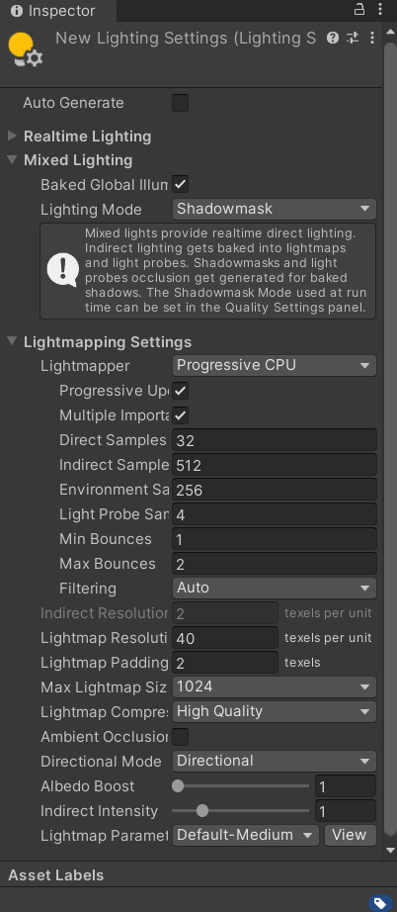

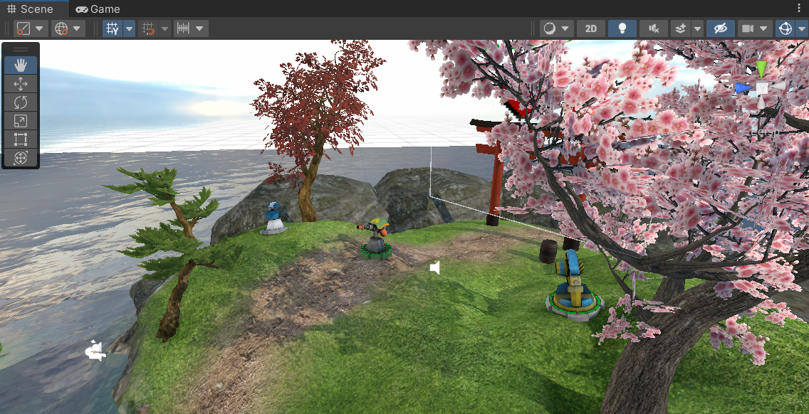

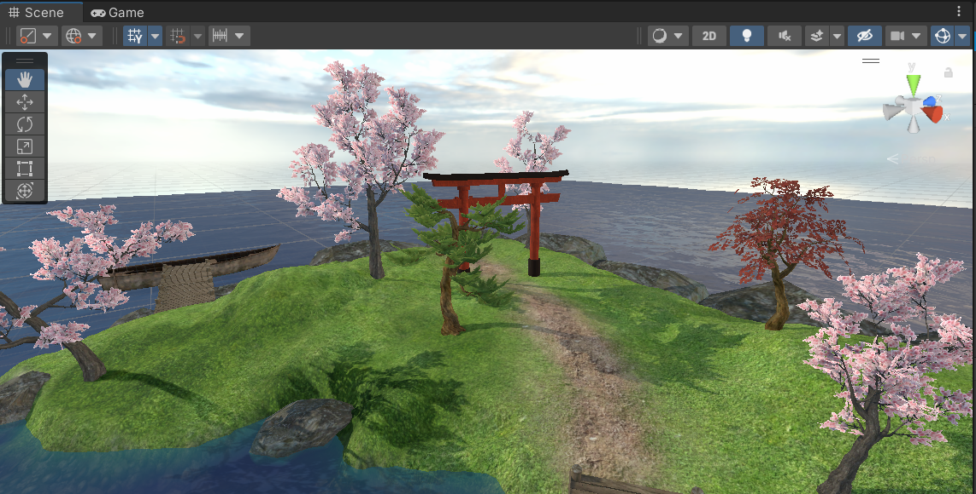

# Task 5: Add Audio

**Actions: -**

* Background Audio: - I used ambient background audio, such as wind and natural noises, to make this setting more appealing.
* Interaction Sounds: - I also incorporated noises such as slicing and item grasping to provide aural input during gaming.

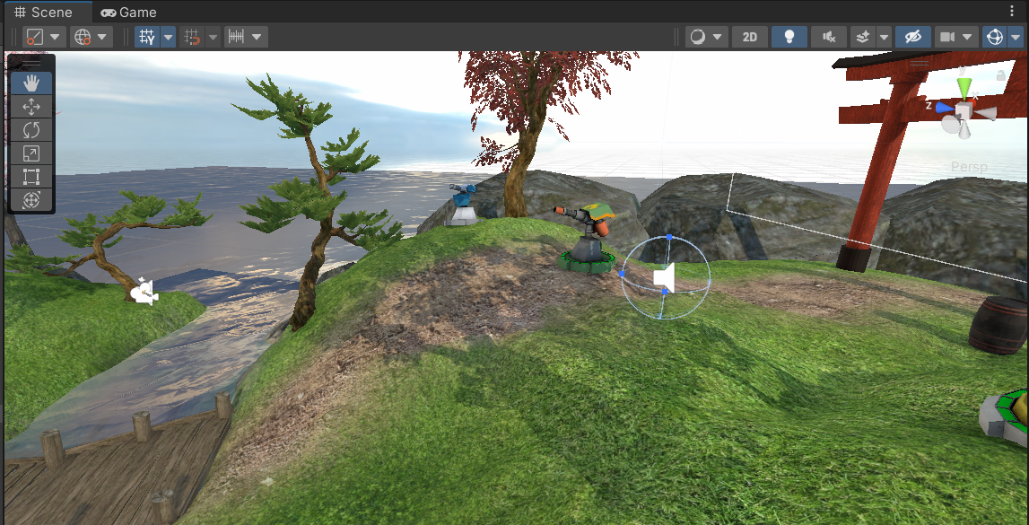

Audio link:- <https://youtu.be/VzMh1O-MJYE?si=wX2Fwnjfm8YtOfKD>

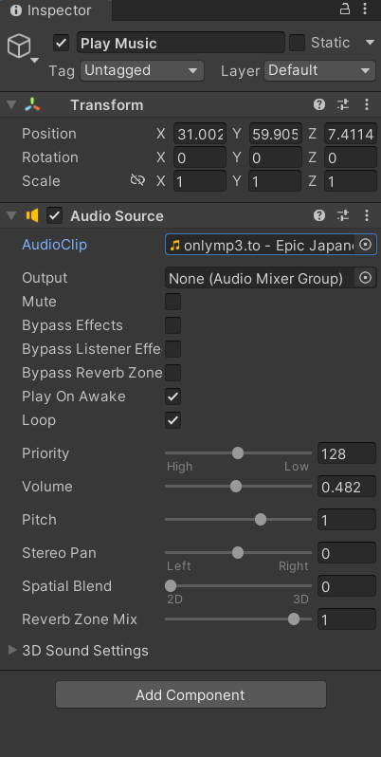

# Task 6: Implement Basic VR Interaction

**Actions: -**

* **Grabbable Objects: -** I used Unity's XR grasp Interactable component to enable VR controllers to grasp and manipulate items.
* **Grabber Components: -** I set up hands in the VR setup as "grabbers" with interaction triggers that detect items.

here is the asset link for sword:-

<https://assetstore.unity.com/packages/3d/props/weapons/rpg-swords-7056>

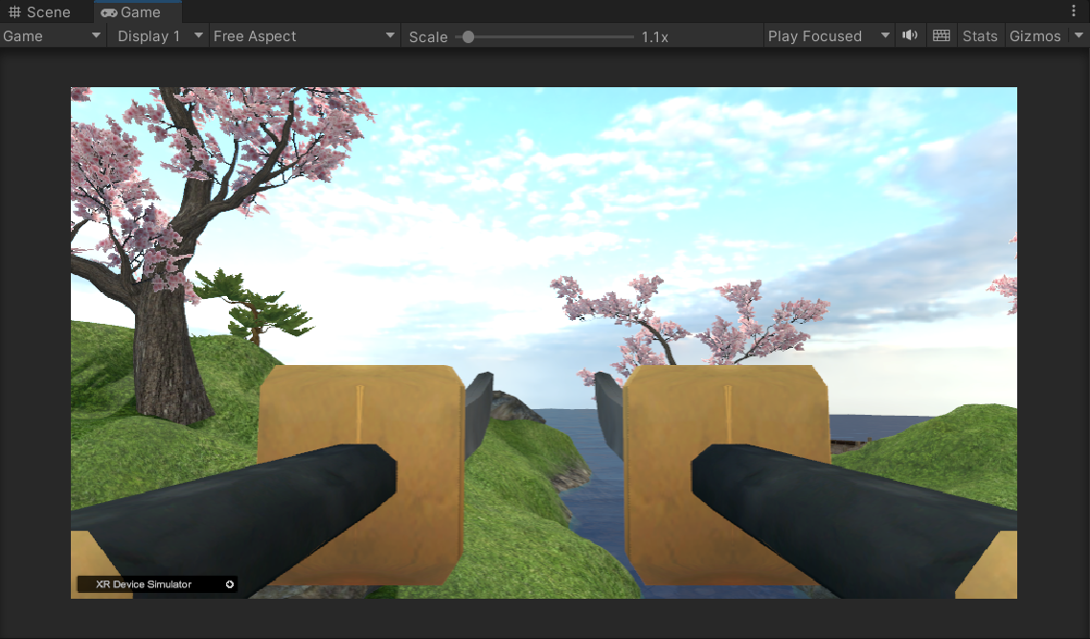

# Task 7: Write the VR Interaction Script

**Actions: -**

* Interaction Script: - I created a C# script to control object grasping and handle the physics when an object is throwing.
* Smooth Movement: - Then I added algorithms to ensure smooth item handling when grasped, hence eliminating jittering and awkward motion in VR.

Here, I write a C# script for generating random fruits and Bomb.

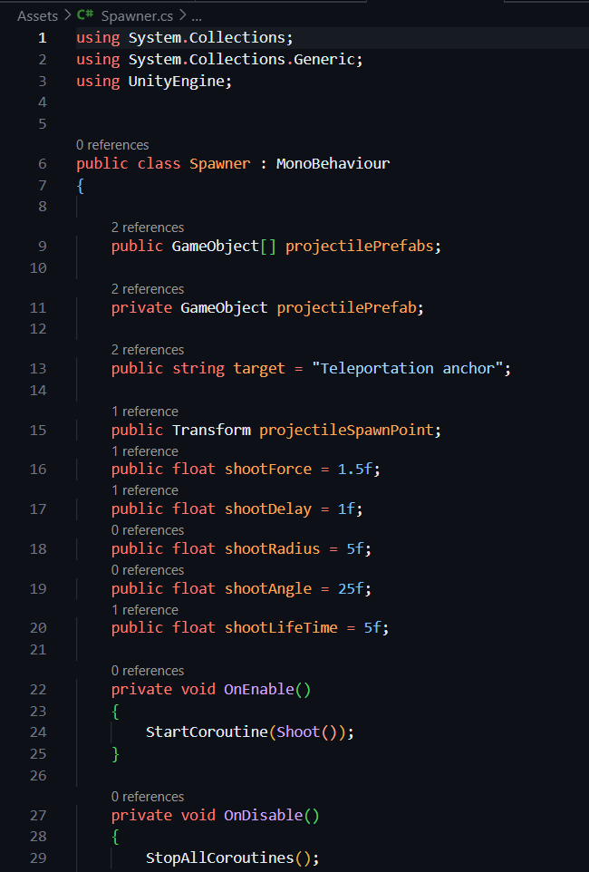

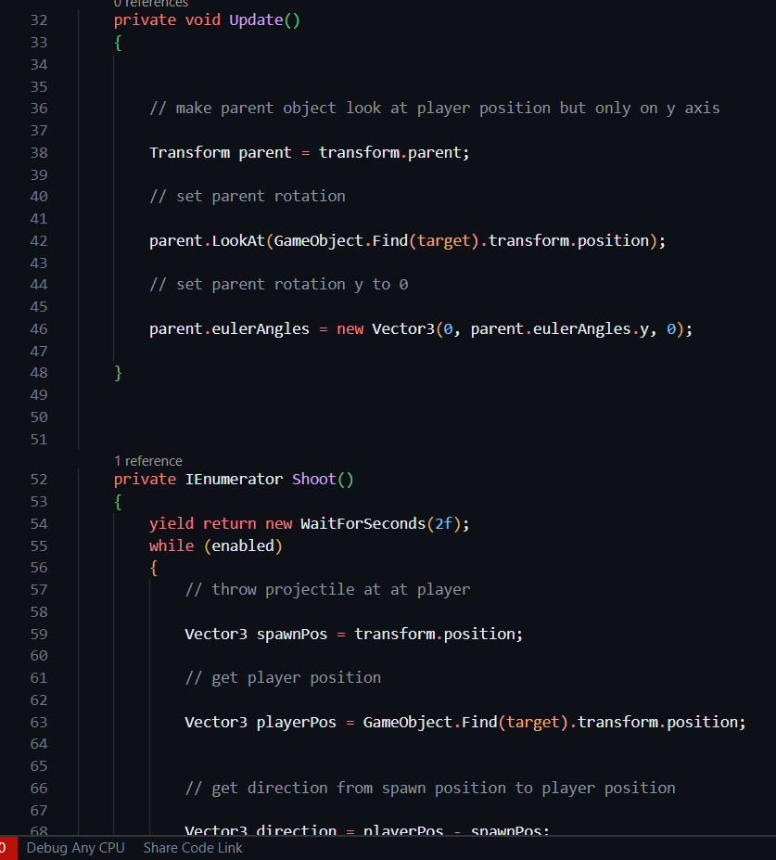

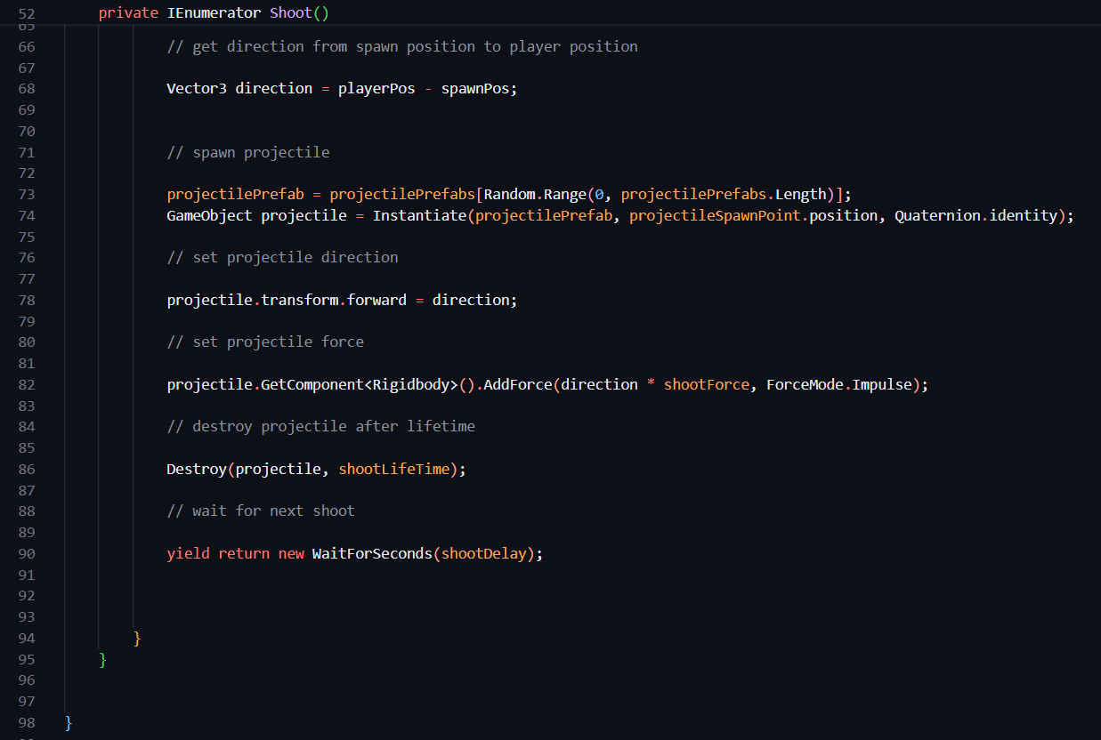

Also, I write a C# script for spawning a random fruit and bomb at a particular time stamp and how much delay for that i write C# script.

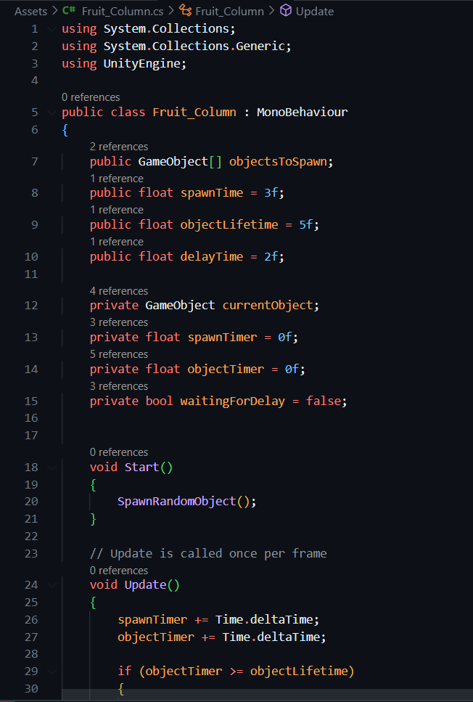

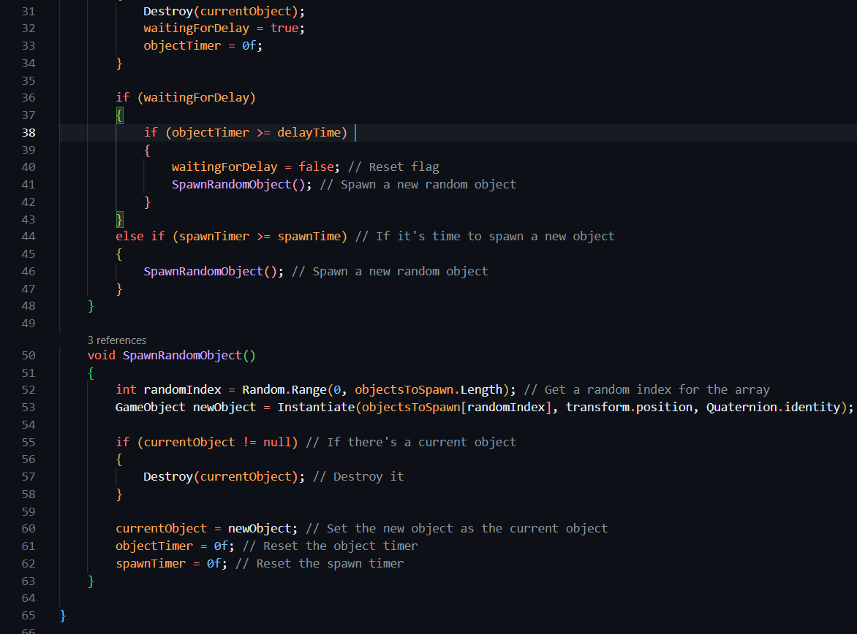

Here is the link of asset for fruits that has been thrown

<https://assetstore.unity.com/packages/3d/props/food/food-grocery-items-low-poly-75494>

# Task 8: Create a Scoring Mechanism

**Actions: -**

* Score System: - I designed a scoring system where players get points for successfully slicing fruit in the air. Also, if a player cuts a bomb, they lose 1 heart. There are three Life.
* UI Display: - Created a score display on the screen that updates in real time based on interactions.

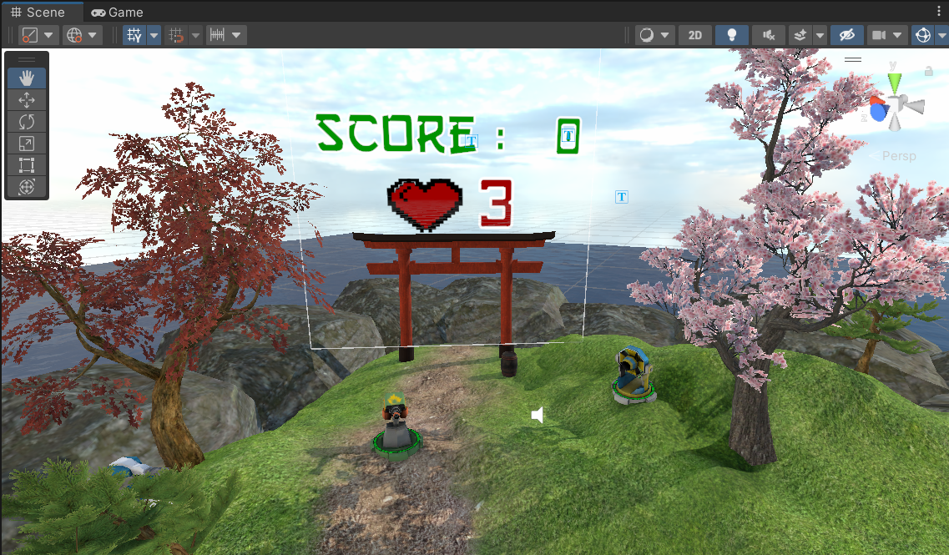

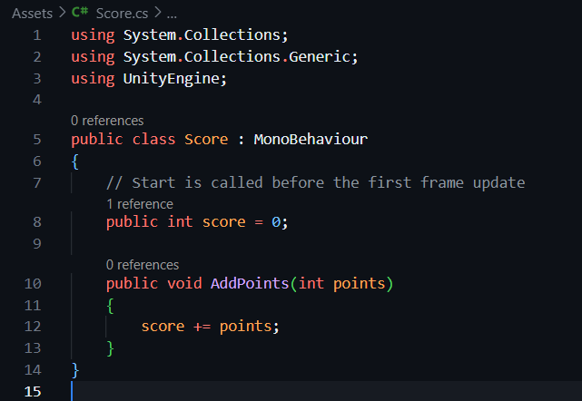

# Challenges and Solutions: -

# Challenge Object Interaction and Physics: -

# Solution: Used Unity's Rigid body and colliders to enhance the slicing physics realistically, with proper interaction detection between the sword and fruits.

# Challenge: Enhanced VR Controls and Slicing Mechanism: -

# Mapped VR controller movements with Unity's XR Interaction Toolkit; now writing custom scripts will allow the precise detection and response of slicing gestures.

# Challenge Overview: Optimizing Performance for Virtual Reality: -

# Solution: Optimized mesh by reducing polygons, using simplified textures, lighting settings correction, and usage of Unity Profiler for making sure the frame rate was always high.

# Challenge: Randomized Fruit Spawning: -

# Wrote a spawn manager script using Unity's Random function to control at what time and location fruits spawn, adding more excitement to the gameplay.

# Challenge: Syncing Audio and Visual Effects Solution: -

# Added audio clips and particle effects for slicing. Was implemented with scripts that trigger effects along with the actions, increasing immersion.

# Conclusion: -

This project helped me further develop my Unity VR development skills through the emphasis of important features such as interacting with objects, scene optimization, and scripting. The difficulty of work, no matter how it has been hard, is the end product that I must achieve: a working virtual reality game that shall be fun and interactive. This overcame many technological barriers and provided valuable educational experiences along the way.

**References: -**

[**https://docs.unity3d.com/Manual/VROverview.html**](https://docs.unity3d.com/Manual/VROverview.html)

[**https://learn.unity.com/tutorial/optimizing-your-vr-ar-experiences#**](https://learn.unity.com/tutorial/optimizing-your-vr-ar-experiences)

[**https://youtu.be/zbqHNwDpi6Y?si=ZWrbhBLWA26d0HLV**](https://youtu.be/zbqHNwDpi6Y?si=ZWrbhBLWA26d0HLV)

[**https://youtu.be/pNhrpdTLMl0?si=mXK4ovgrGApyD_gF**](https://youtu.be/pNhrpdTLMl0?si=mXK4ovgrGApyD_gF)